DAY-2 Maven
How to create a maven project.
Steps-
- Create folder in side your local machine named it as maven-project.
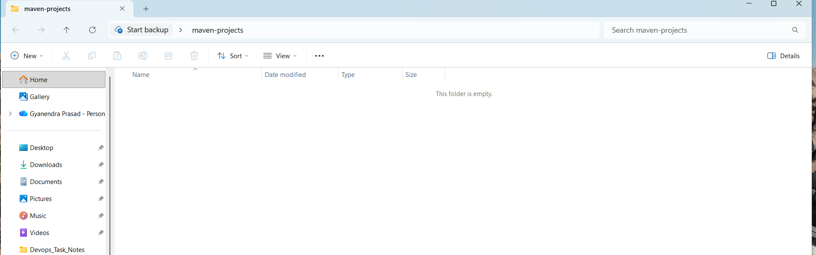
- Inside this folder open the command prompt.
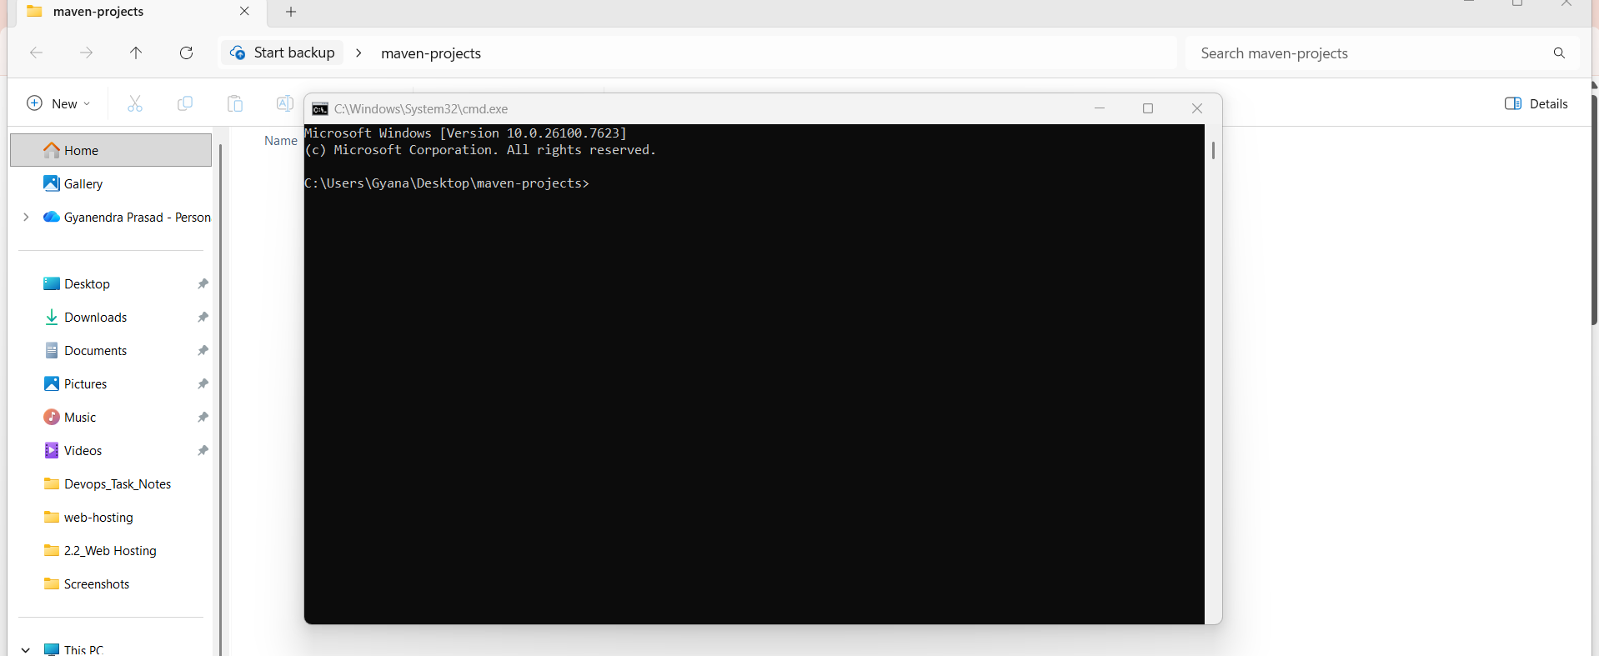
- I want to create a stand alone application so enter this command here.
Syntax:
mvn archetype:generate -DgroupId=com.yourcompany.app -DartifactId=my-app -DarchetypeArtifactId=maven-archetype-quickstart -DinteractiveMode=false
ex:
mvn archetype:generate -DgroupId=com.kubebytes -DartifactId=my-app-01 -DarchetypeArtifactId=maven-archetype-quickstart -DarchetypeVersion=1.5 -DinteractiveMode=false
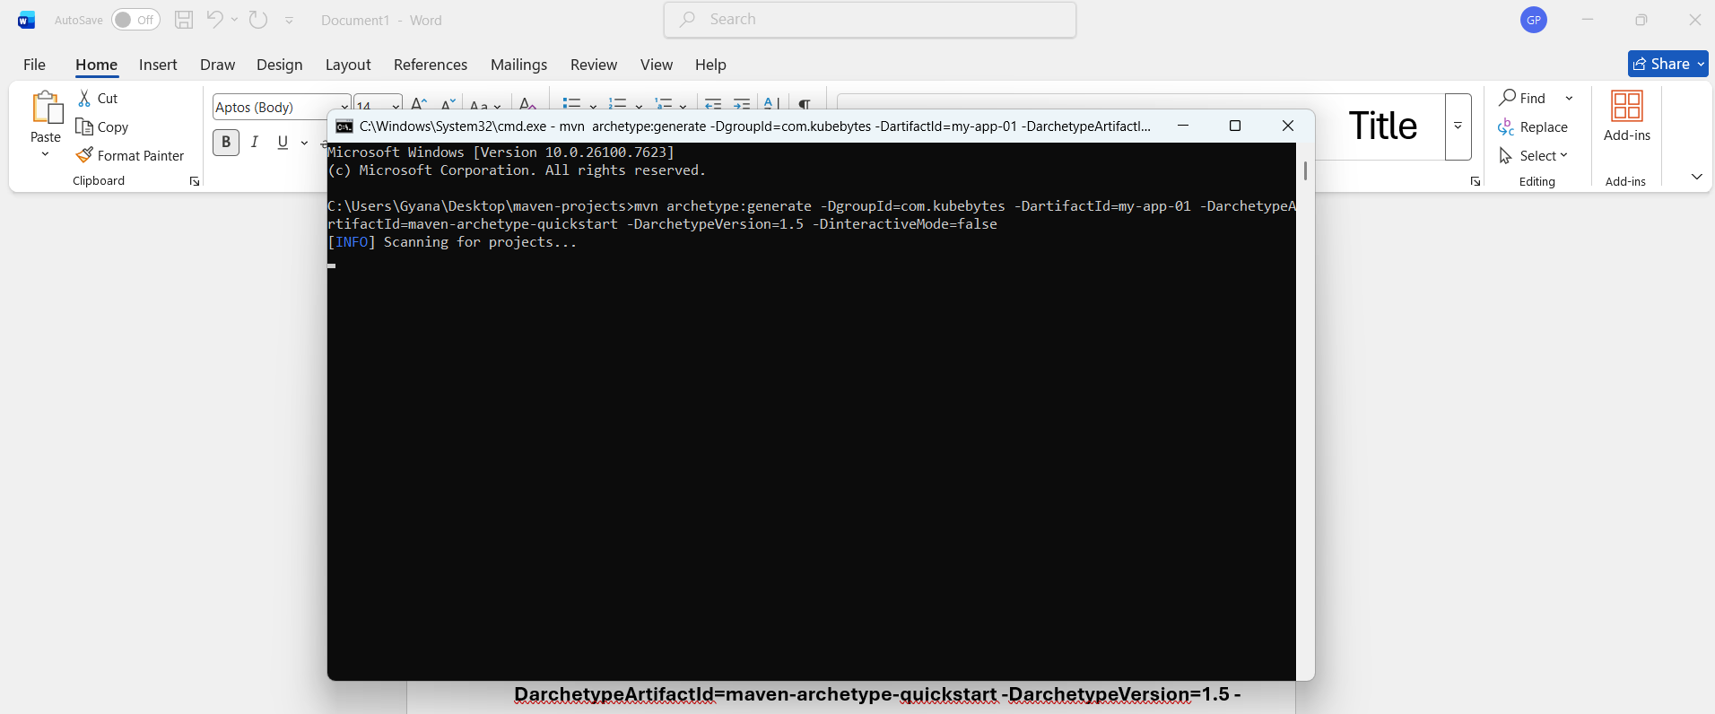
- After hitting this command it will crate a stand alone application.
- Project created from Archetype in dir: C:\Users\Gyana\Desktop\maven-projects\my-app-01 this message is showing confirmation of creating a project my-app-01
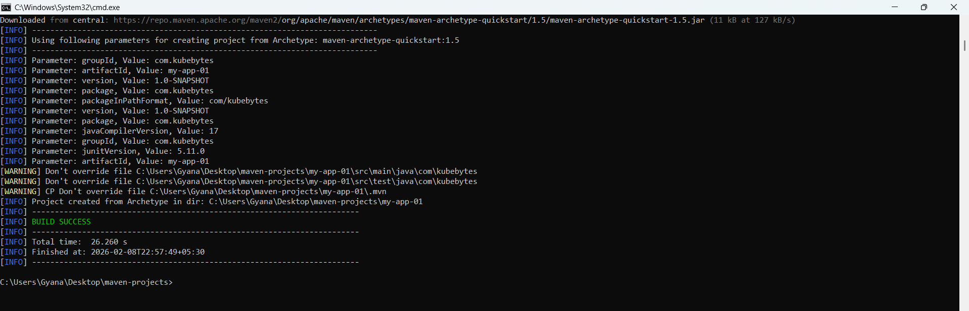
- Now Open the visual studio code.
- Inside this VS CODE open the project folder maven-projects which created in destop.
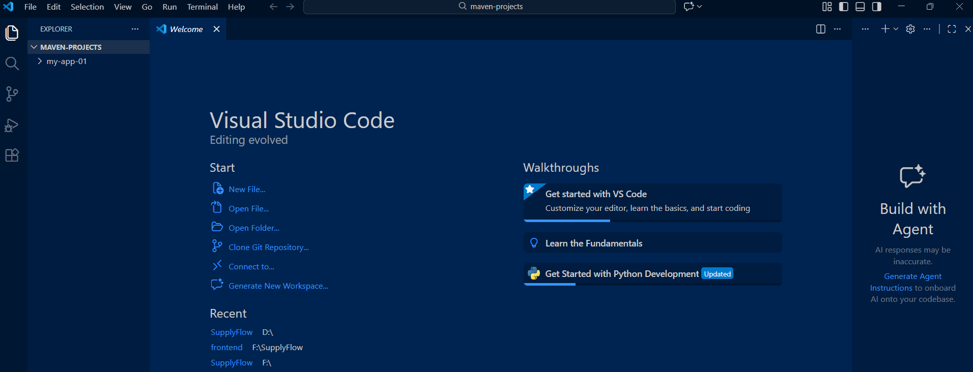

- See the folder structure of the project which is nothing but the project structure of java.
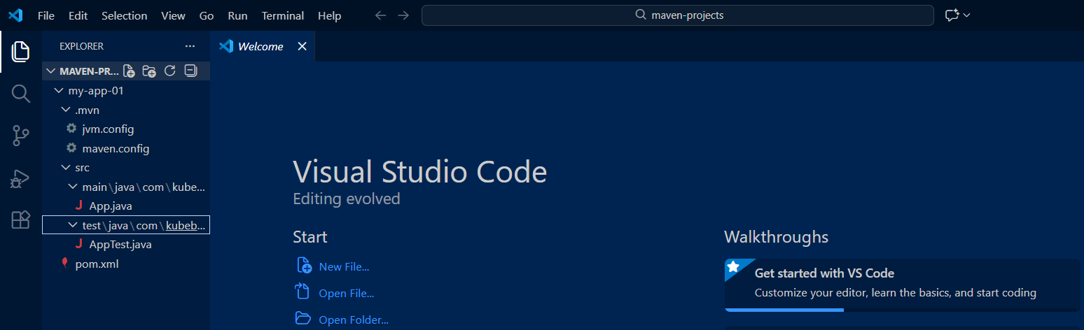
i) Now as a devops engineer our work is to execute the Maven goals.
j) Now click the toggle pannel and open the terminal inside the vs code.
k) Now change the terminal from powershell to Git bass which will show we are inside the maven-projects.
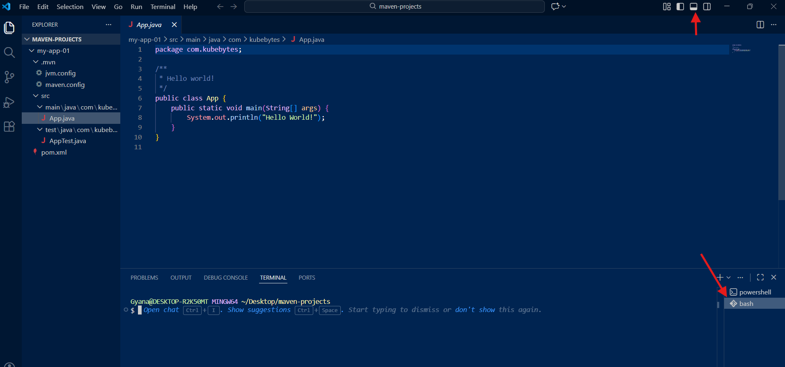

- Go inside the project folder my-app-01 because every time the maven goals is to execute inside the project folder.
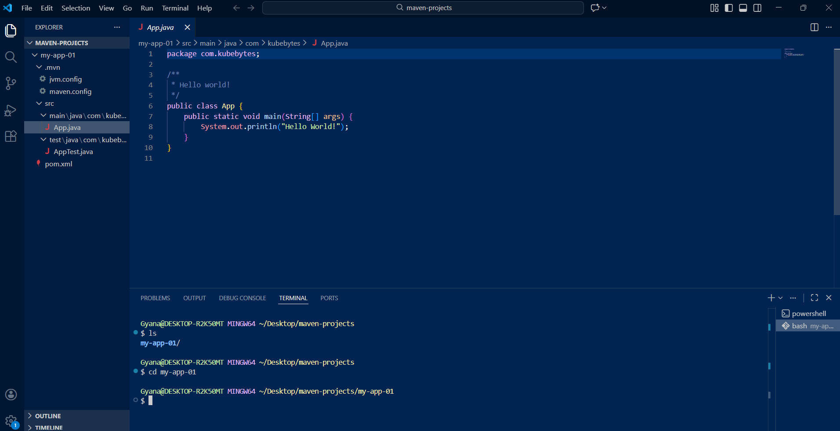
- Now perform the maven goals.
- Use the command mvn compile to compile the code.
- After compile and BUILD SUCESS a folder will generate which is nothing but a Target folder.
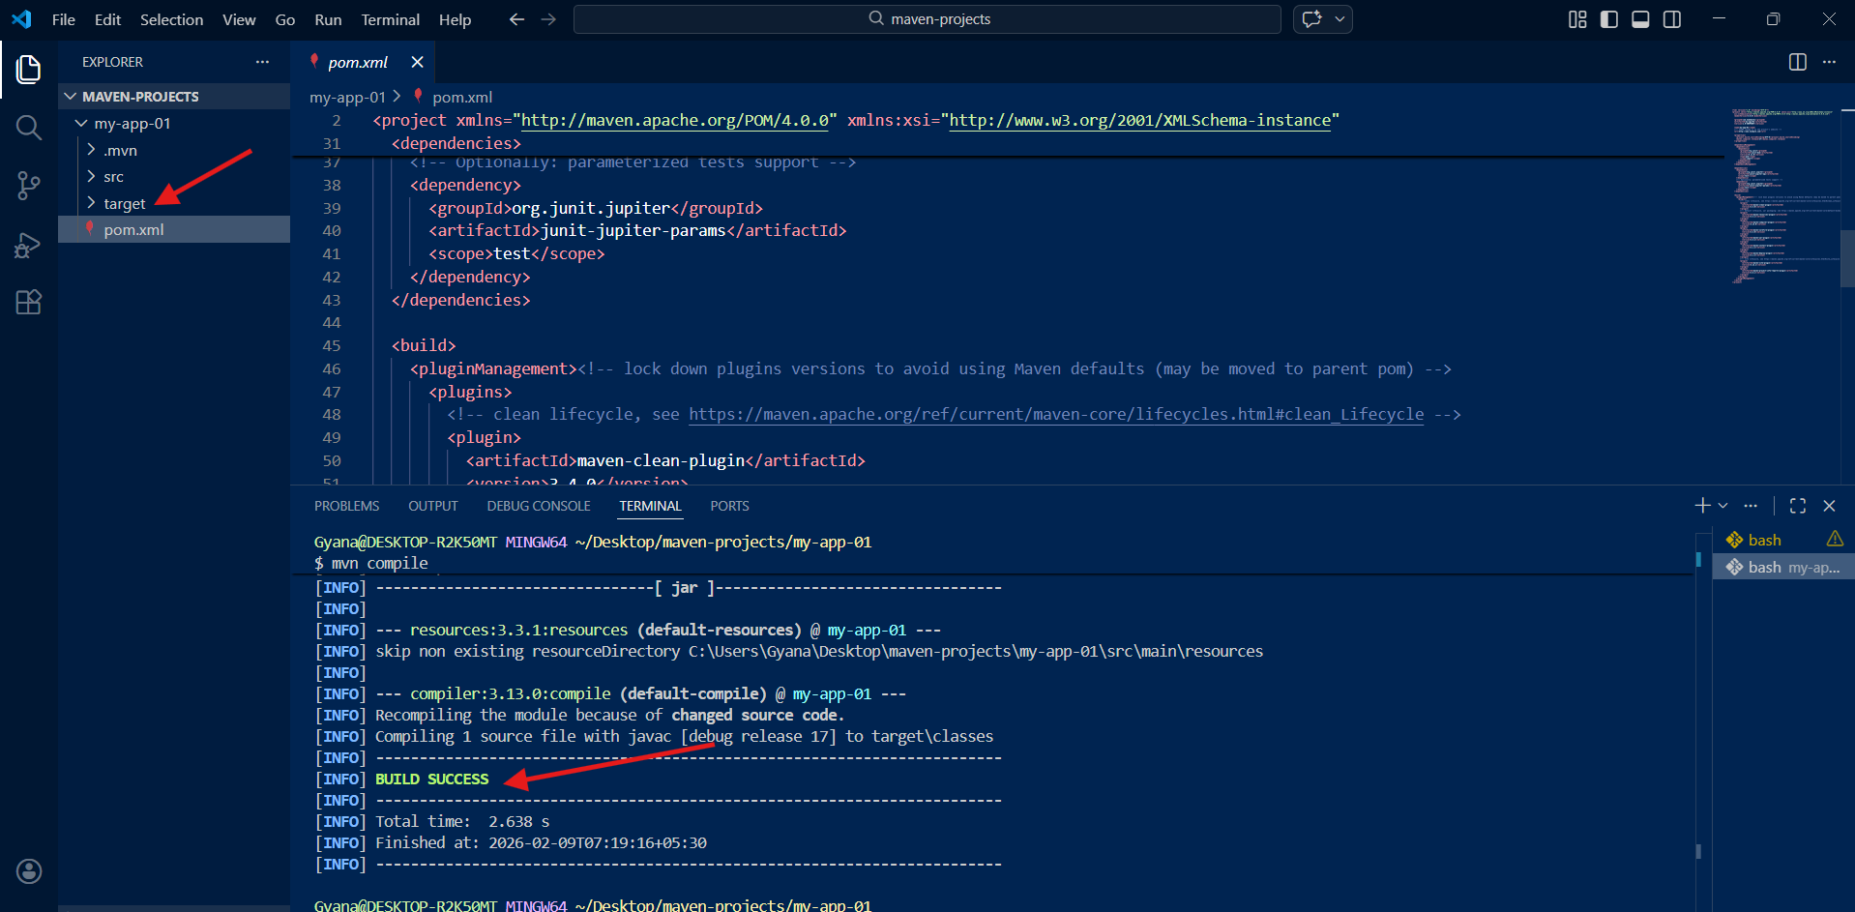
- After compilation we will host our code.
- The next maven goal will be : mvn test which will test my code that my code is correct or not.
- If it will show BUILD SUCCESS then or code tested successfully
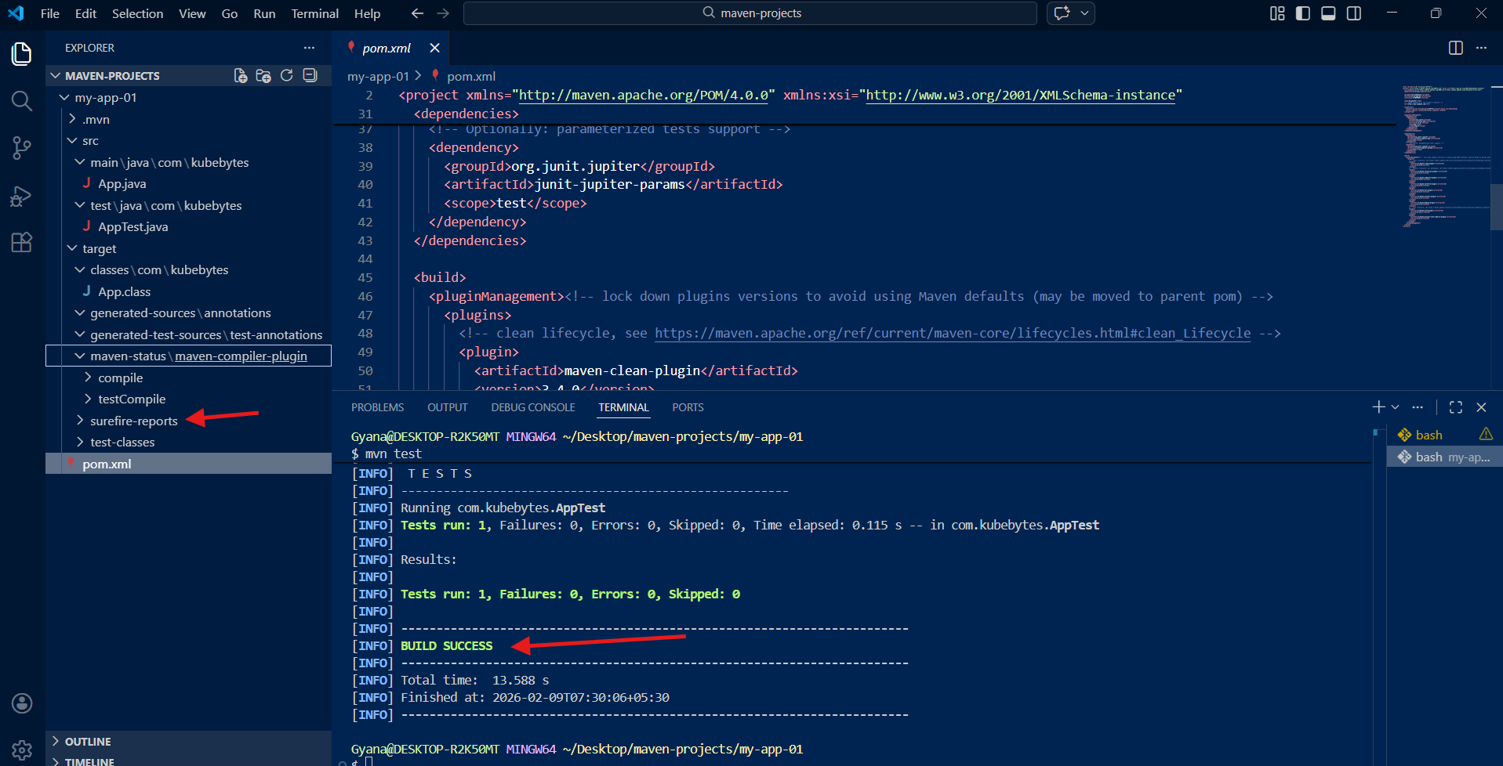
- Now will execute the maven goal mvn package.
- It will packet our code to create a .jar or .war files.
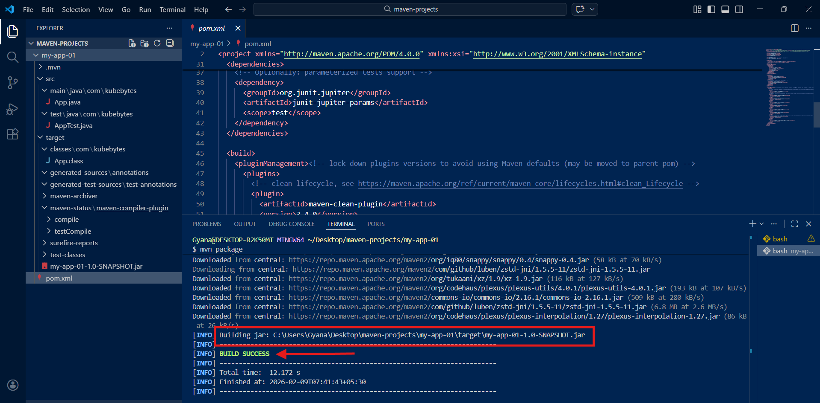
In the above image a SNAPSHOT.jar file got created when we execute the goal mvn package.
SNAPSHOT: It means our project is UNDER DEVELOPMENT
That SNAPSHOT will create under this path: C:\Users\Gyana\Desktop\maven-projects\my-app-01\target\my-app-01-1.0-SNAPSHOT.jar .
Which is nothing inside the my-app-01 project inside the target folder.
RELEASE: It means our project is delivered to client.

- Before adding the dependency I will clean my application using mvn clean
- Then add the Dependencies to the pom.xml file.
- The default Dependency for the stand-alone application is junit.
- I am adding new dependencies from maven central repository.
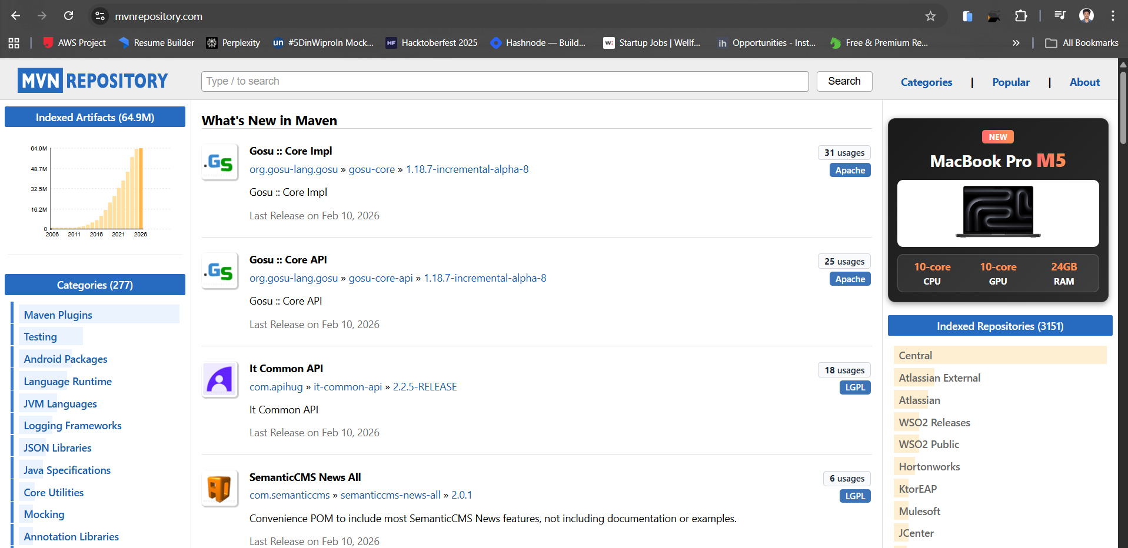
- Copying the dependency form this central repository.
- Added the dependency in the dependencies section.
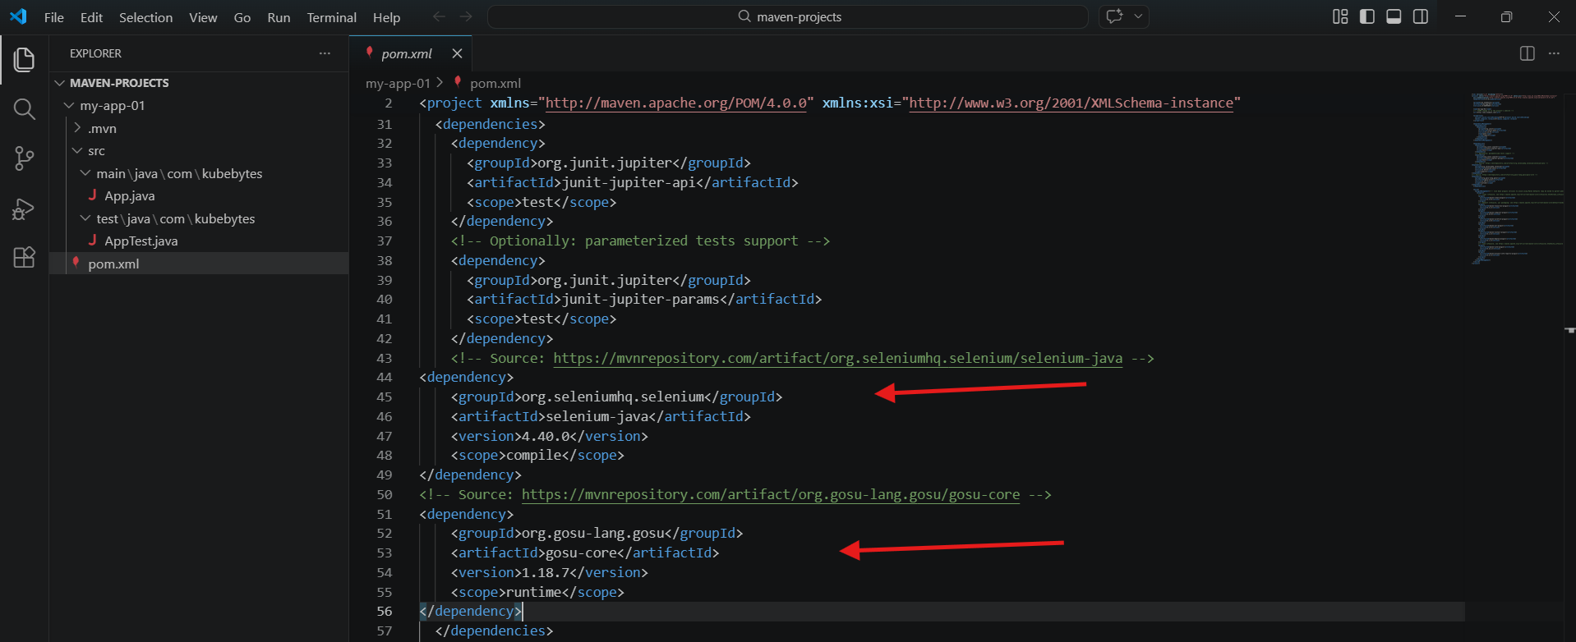
Now I running the maven goals.
- mvn compile : to compile the codes and a target folder got created this get download from the central repository
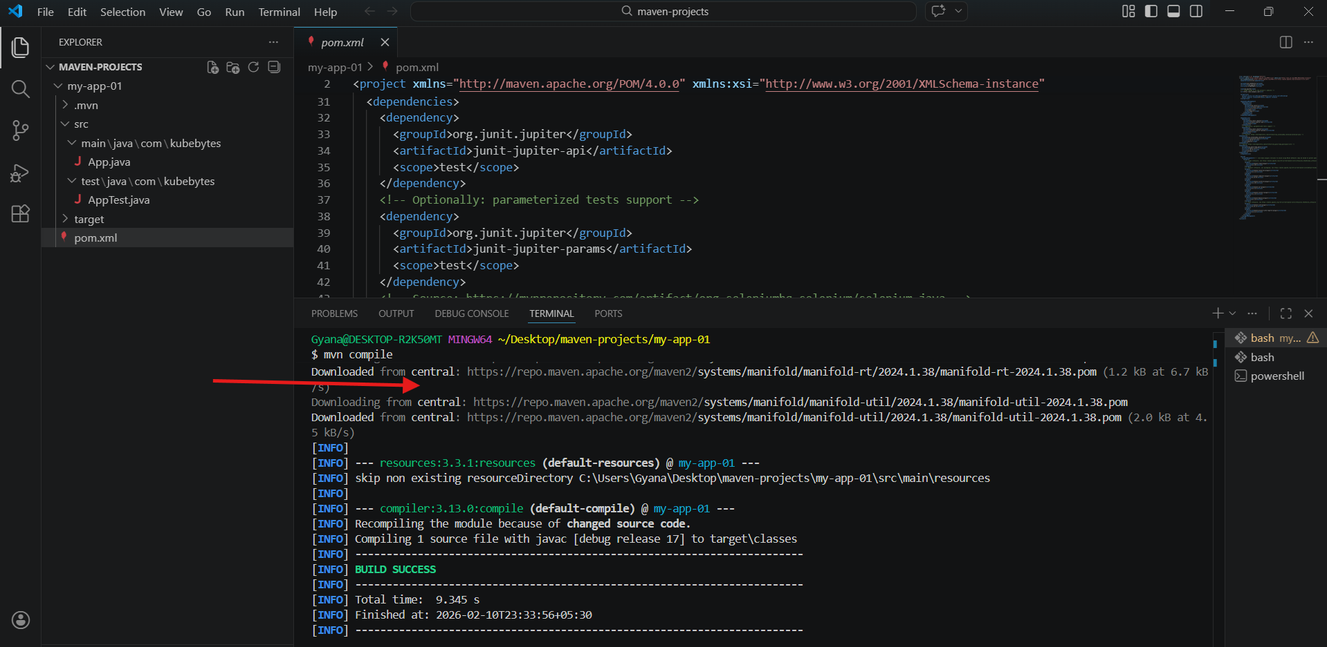
- But when we clean our environment using mvn clean and then after run the mvn compile this time it will be downloaded from the local repository.
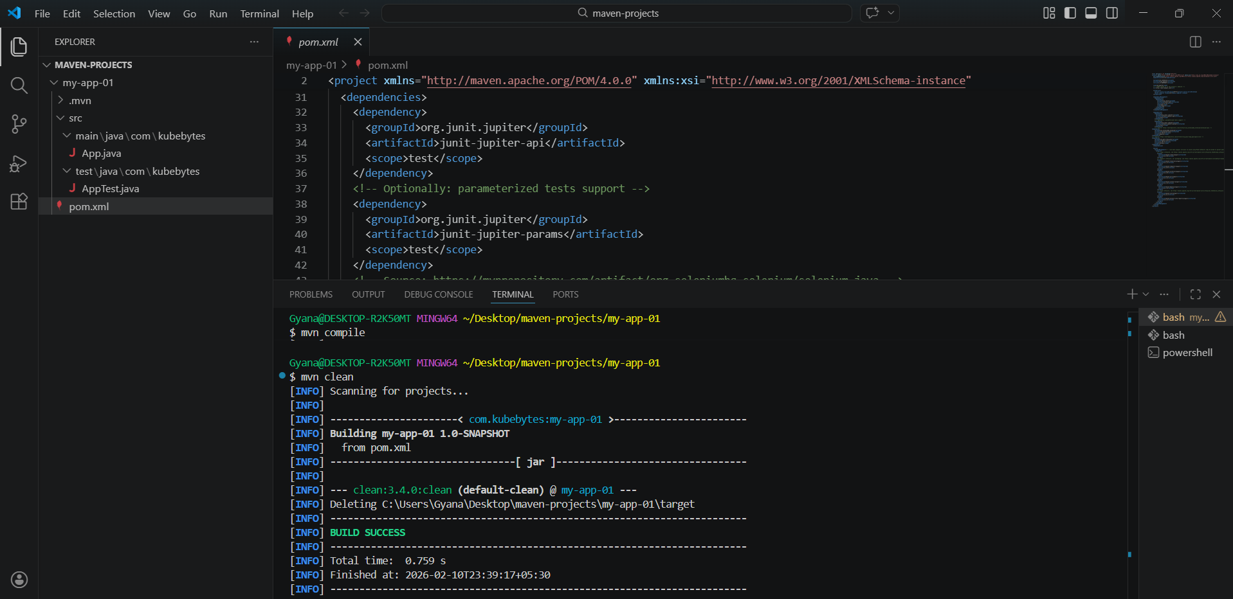
- Now running mvn compile again.
- Look it has downloaded from the local repository.
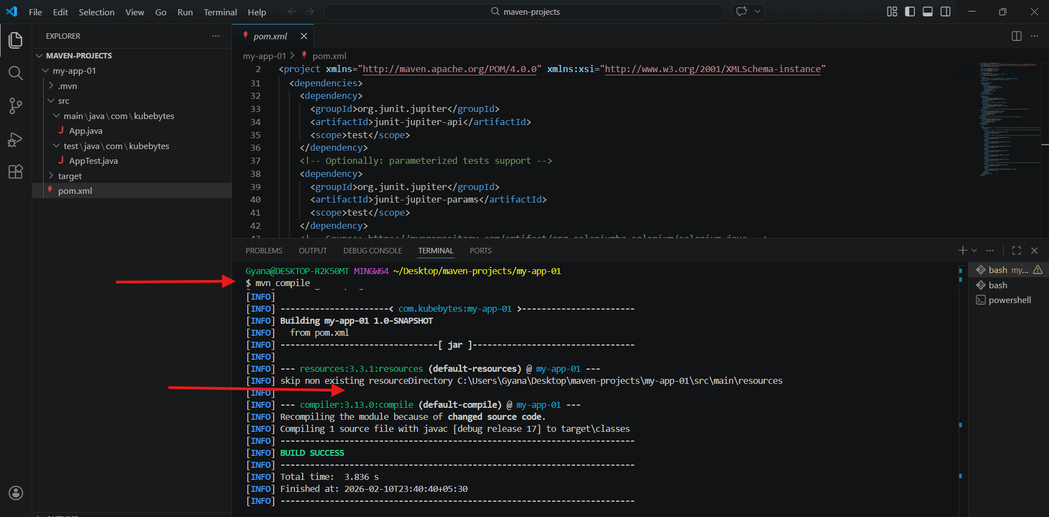
- The local repository will be created in our machine as .m2 folder which is inside our User .
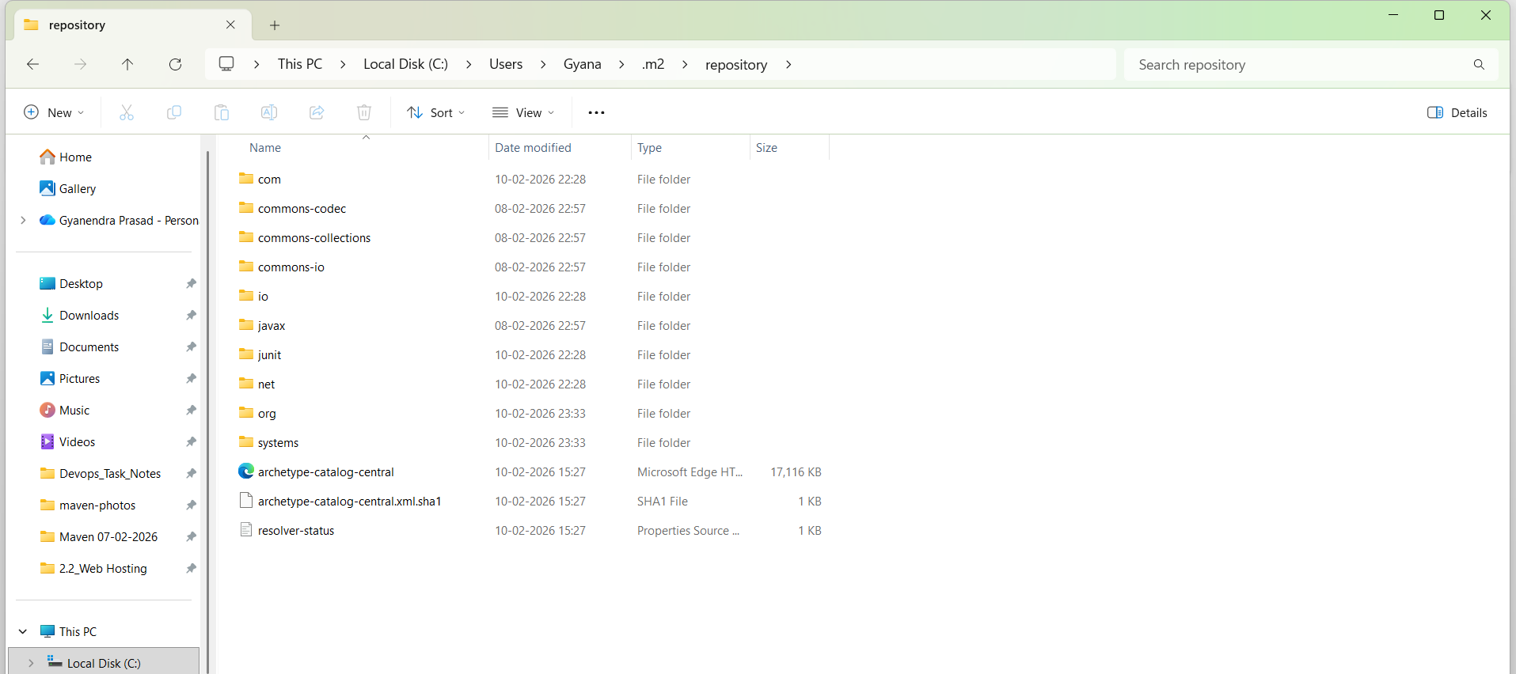
- If we add any other dependency or make any changes in our pom.xml file and clean the environment and run the commands then it will again start downloading from the central.
- Here I have added another dependency in pom.xml and run the mvn test again.
